CHAPTER 4: CODING AND TESTING

4.1. INTRODUCTION
The objective of this chapter is to build and test a reliable information system with trained users ready to benefit as expected from use of the system. Coding is the physical creation of the system programs. The system will be programmed using VB.Net which is a scripting language and My SQL for Database Management System.

4.2. TECHNICAL DOCUMENTATION
This section presents the system code of the system according to the functions to be performed.

4.2.1. Code for connecting to the database

Imports MySql.Data.MySqlClient
Module Db_Conn
Dim MysqlConn As New MySqlConnection

Public Function myconn() As MySqlConnection

Return New MySqlConnection(My.Settings.mydbConnection)

End Function
End Module

4.2.2. Code for system log in

If btnLogin.Text = "Click Here to Login" Then
btnLogin.Text = "Login"
gLoginForm.Visible = True
lblError.Visible = False
End If
If txtUser.Text = "" Then
lblError.Text = "Username is required Please"
lblError.Visible = True
ElseIf txtPass.Text = "" Then
lblError.Text = "Password is required Please"
lblError.Visible = True

Else
sql = "SELECT * FROM `usersaccount` WHERE `username`='" & txtUser.Text & "' AND `password`='" & txtPass.Text & "' "
bookfindthis(sql)

If GetNumRows() = 1 Then
MsgBox("Logged in Successfully", MsgBoxStyle.Information)
LoadSingleResult("login")
txtPass.Text = ""
txtUser.Text = ""

4.2.3. Code for student registration

issucess = book_insert("INSERT INTO `student_details` (`regNumber`, `name`, `surname`,`dateOfBirth`, " &
" `gender`, `nationality`, `class`, `term`, `address`, `fatherName`, `occupation`, `phone`) " &
" VALUES ('" & txtReg.Text & "','" & txtFname.Text & "', '" & txtSurname.Text & "', '" & txtDOB.Text & "', '" & cboGender.Text & "', '" & txtNational.Text & "', " &
" '" & cboClass.Text & "', '" & cboTerm.Text & "', '" & txtAddress.Text & "', '" & txtFather.Text & "', '" & txtOcpy.Text & "', '" & txtPhone.Text & "');")

If issucess = True Then
MsgBox("New student has been added successfully!")
StudentsList.Show()
Me.Hide()

End If

4.2.4. Code for updating student details
issucess = book_insert("UPDATE `student_details` SET `name`='" & txtFname.Text & "',`surname`= '" & txtSurname.Text & "',`dateOfBirth`='" & txtDOB.Text & "',`gender`= '" & cboGender.Text & "',`nationality`= '" & txtNational.Text & "'," &
"`class`='" & cboClass.Text & "',`term`= '" & cboTerm.Text & "',`address`='" & txtAddress.Text & "',`fatherName`= '" & txtFather.Text & "', `occupation`='" & txtOcpy.Text & "',`phone`='" & txtPhone.Text & "' WHERE `regNumber`='" & txtReg.Text & "'")

If issucess = True Then
MsgBox("Student has been updated successfully!", MsgBoxStyle.Information)
StudentsList.Show()
Me.Hide()
txtReg.Clear()
txtFname.Clear()
txtSurname.Clear()
txtDOB.ResetText()
cboGender.ResetText()
cboClass.ResetText()
cboTerm.ResetText()
txtNational.Clear()
txtAddress.Clear()
txtFather.Clear()
txtOcpy.Clear()
txtPhone.Clear()
Else
lblError.Text = "No student has been updated!"
lblError.Visible = True

4.2.5. Code for book entry

If btnReg.Text = "Save Book" Then

bookfindthis("SELECT COUNT(*) FROM `bookdetails` WHERE `acconmber`='" & txtssn.Text & "'")

If GetCount() > 0 Then
MsgBox("Please Book SSNB is already exist Please!")
lblError.Text = "No New Book has been added!"
lblError.Visible = True
Else

If txtssn.Text = "" Then
MsgBox("Reg Number is Required!", MsgBoxStyle.Critical)
ElseIf txtAuthor.Text = "" Then
MsgBox("Auther is Required!", MsgBoxStyle.Critical)
ElseIf txtbkT.Text = "" Then
MsgBox("Title is Required!", MsgBoxStyle.Critical)
ElseIf txtPubl.Text = "" Then
MsgBox("Publication is Required!", MsgBoxStyle.Critical)
ElseIf txtEdit.Text = "" Then
MsgBox("Edition is Required!", MsgBoxStyle.Critical)
ElseIf txtCopies.Text = "" Then
MsgBox("Number of Copies is Required!", MsgBoxStyle.Critical)
ElseIf txtVolume.Text = "" Then
MsgBox("Volume is Required!", MsgBoxStyle.Critical)
ElseIf txtDOB.Text = "" Then
MsgBox("Date of Publication is Required!", MsgBoxStyle.Critical)
ElseIf txtPurch.Text = "" Then
MsgBox("Price of book is Required!", MsgBoxStyle.Critical)

Else
issucess = book_insert("INSERT INTO `bookdetails` (`acconmber`, `author`, `title`,`publication`, " &
" `edition`, `numberofCopies`, `volume`, `date_purchased`, `price`) " &
" VALUES ('" & txtssn.Text & "','" & txtAuthor.Text & "', '" & txtbkT.Text & "', '" & txtPubl.Text & "', '" & txtEdit.Text & "', '" & txtCopies.Text & "', " &
" '" & txtVolume.Text & "', '" & txtDOB.Text & "', '" & txtPurch.Text & "');")

If issucess = True Then
MsgBox("New Book has been added successfully!")
BookList.Show()
Me.Hide()

4.2.6. Code for issuing books

'Save Borrower
If btnReg.Text = "Save Borrower" Then
sql = "SELECT * FROM `borrowed` WHERE `ssnb`='" & txtssn.Text & "' "
bookfindthis(sql)

If GetNumRows() = 1 Then
MsgBox("This book has been borrowed ", MsgBoxStyle.Critical)
Else

issucess = book_insert("INSERT INTO `borrowed` (`regNumber`, `fullName`, `gender`, `class`,`address`, " &
" `ssnb`, `author`, `title`, `date_returned`, `numOfDays`, `processed_by`) " &
" VALUES ('" & txtReg.Text & "','" & txtFullN.Text & "','" & cboGender.Text & "', '" & cboClass.Text & "', '" & txtAddress.Text & "', '" & txtssn.Text & "', '" & txtAuthor.Text & "', " &
" '" & txtbkT.Text & "', '" & DateTimePicker2.Text & "', '" & txtN.Text & "', '" & lblLogout.Text & "');")
If issucess = True Then
MsgBox("You have Issued book to '" & txtFullN.Text & "' successfully! Book will be return on '" & DateTimePicker2.Text & "'", MsgBoxStyle.Information)
book_insert("UPDATE bookdetails SET status= 'Unvailable' WHERE acconmber='" & txtssn.Text & "'")
Else
lblError.Text = "No Book has been issued to '" & txtFullN.Text & "'!"
End If
End If

4.2.7. Code for listing books

Try
bookfindthis("SELECT * FROM `bookdetails` WHERE `acconmber`='" & txtSearch.Text & "' Or `title`='" & txtSearch.Text & "' Or `author`='" & txtSearch.Text & "'")
LoadData(GridBooks, "bookList")
Catch ex As Exception
MsgBox(ex.Message)
Finally
con.Close()
da.Dispose()
End Try

4.2.8. Code for listing students

4.3. UNIT AND SYSTEM TESTING
4.3.1. Unit Testing
This is a testing procedure in which the single components of computer software are tested. It is a software development process that focuses on inspecting the proper operation of system units individually and independently www.softwaretestingfundamentals.com. The rationale is to certify that each unit of the computer software performs as intended by isolating a selected section of the code and ascertain its accuracy. Furthermore, unit testing is preferred because it is assumed that it is easier to recognise an error in a single module than the whole system. In most cases unit testing is done using a single or few system inputs to produce a single output. Unit testing is done using black-box and white-box testing procedure. The purpose of unit testing was to verify whether individual components were running as expected. All unit tests were performed independently of other system components. The following components were required:
- Missing information

Figure 4.1: Showing the results of missing information
- Display data on forms
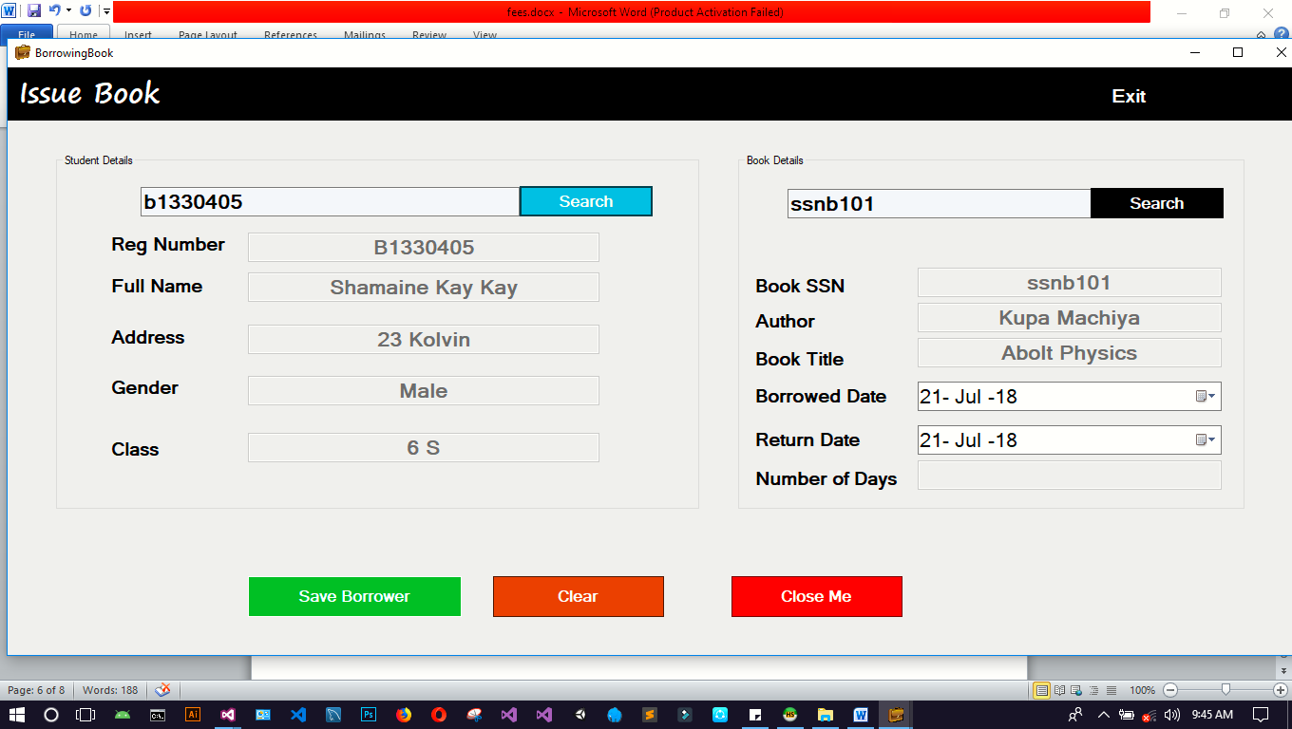
Figure 4.2: Displaying data on the forms

- Query function
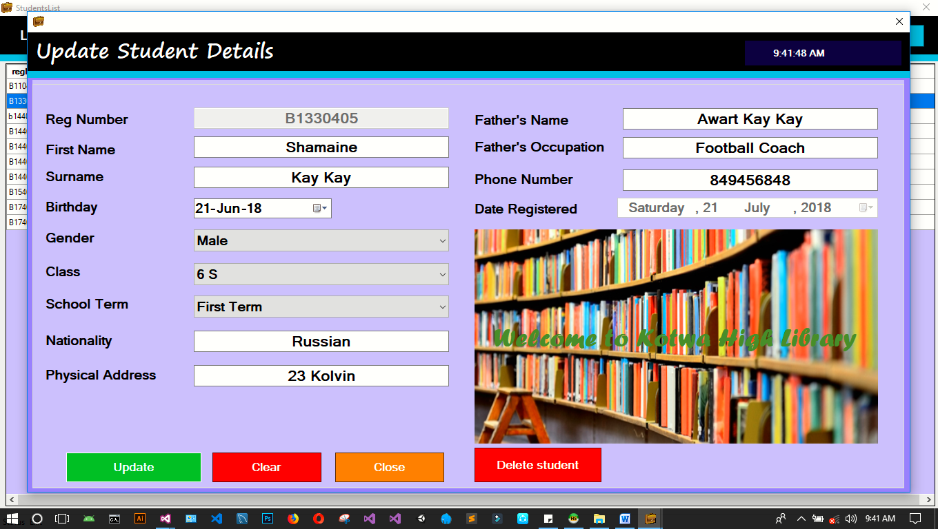
Figure 4.3: Query for updating the database
- Displaying of the output from the database
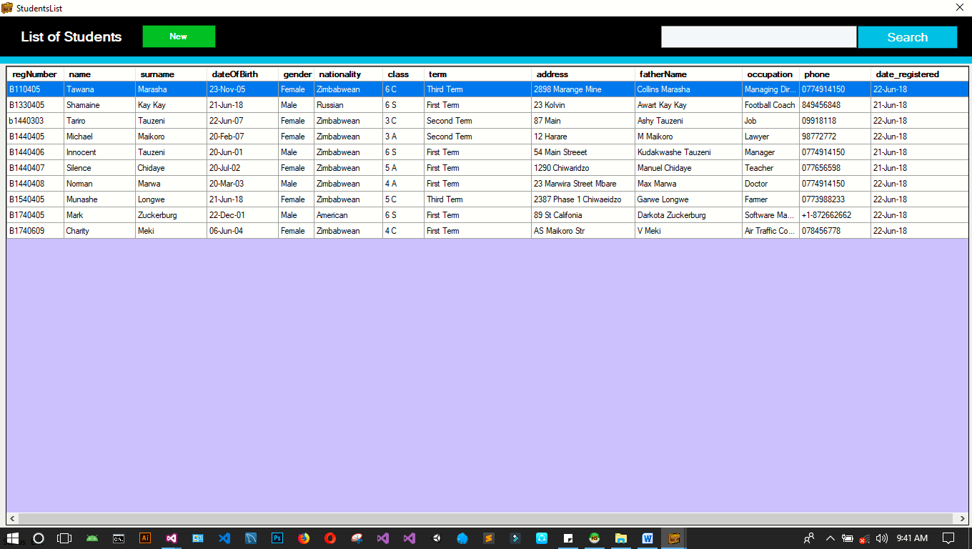

Figure 4.4: Displaying of the output from the database

4.4. USER TESTING
User testing was guided by the objectives of the project defined in Chapter 1 as follows:
- Adding student details to the system
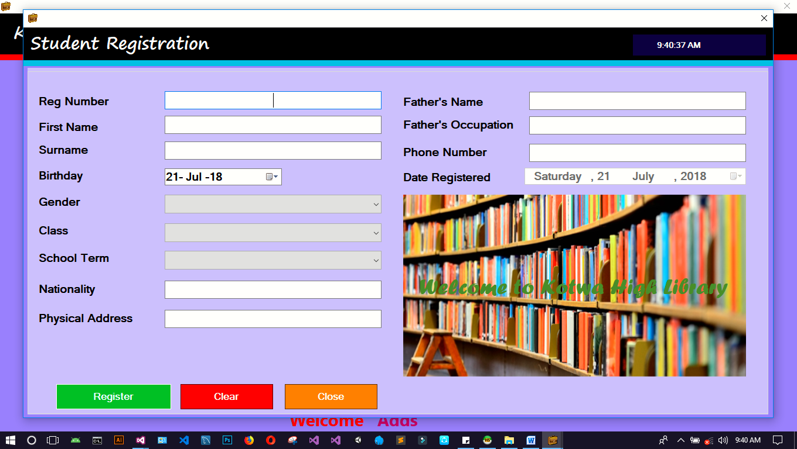
Figure 4.5: Adding student details to the system
- Adding details of new book in database with the help of unique id
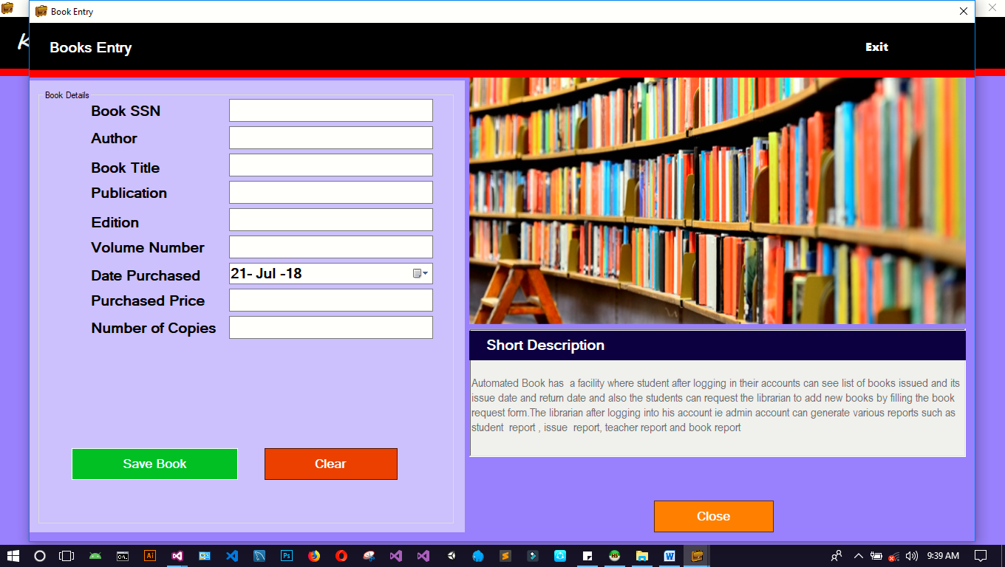
Figure 4.4: Adding details of new book in database

- Issuing books to the students

- Generate list of books issued to pupils
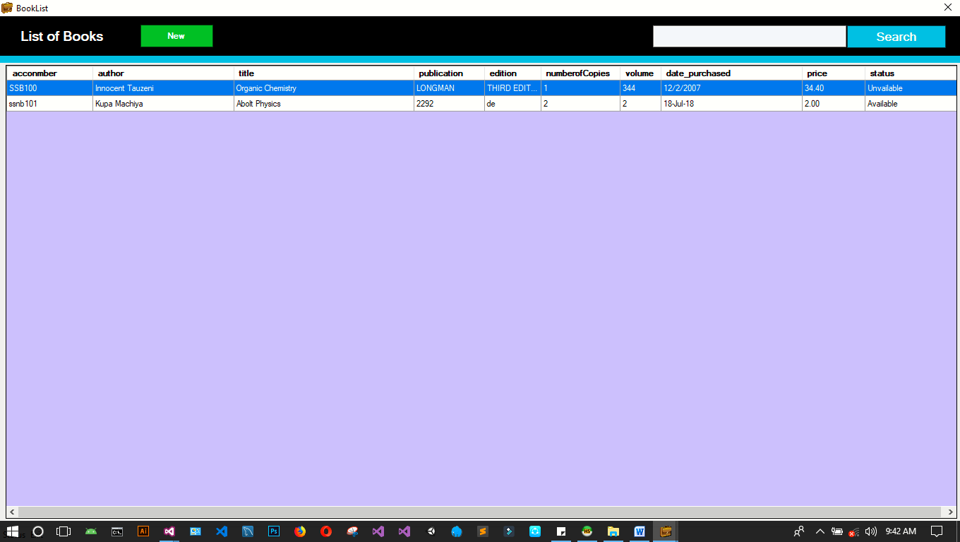

4.5. CONCLUSION
This chapter presented the code for the system for various components and functionalities. The chapter also presented the unit and the system tests and the test results that are performed by the system. The next chapter focuses on the implementation of the system.

